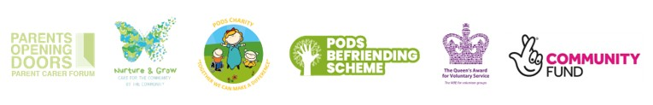
ONE COMMUNITY CONFERENCE FEEDBACK MARCH 2026
We gathered feedback from attendees with hearts (working well) and speech bubbles (could be better). We gave families the opportunity to share their experiences of anything that was important to them at the time, as it was an emotional day, we wanted to showcase the importance of bringing everyone together to share thoughts and feelings in a safe environment.
These responses demonstrate the importance of support and acknowledgment of feelings of being a parent carer.
Feedback into strategic meetings will of course take place. We will also look at some signposting, information onto Local Offer and a series of FAQs.
WORKING WELL  - Understanding friends, sticking with me  - Makaton symbols  - Southall School  - Young carers (x2)  - SEND school understanding/supportive  - 1:1 Asst Psychology appointments to book onto while waiting  - PODS counselling – excellent  - PRH Staff/paramedics – understanding  - The Bridge school – Amazing! (x2)  - Autism hub courses with Sam  - Speech and Language  - Being out with adults  - Supportive relationships  - Supportive school – Haughton  - Support at school with amazing communication, working with parents as partners  - My garden  - School and college  - PODS support and sessions (x3)  - Ipad limits  - Understanding by BeeU, now finally at top of list  - Some excellent GP/physio support – giving more time and explaining well  - Volunteering and working with children  - Sensory Inclusion fantastic with hearing aids and advice  - Looking after my grandchildren and watching them grow. | COULD BE BETTER  - More outdoor events in Spring  - Summer support groups  - Autism hub daytime support group for PC  - More support whilst on pathway  - Services for holidays  - Respite in holidays  - Need paid work for young person – very anxious since out of work  - More training in schools  - Being honest with family  - The news!  - Current affairs in the world  - I’m very tired  - Provision in holiday (x3)  - Communication  - Access to groups and support post 16  - Lack of help from services  - School funding to meet need and behaviour  - Managing meltdowns  - Access to support of external services (joined up services)  - Sam route for every child on ND pathway (everyone in ND family)  - Where to go for respite  - More ‘me’ time  - Friendships  - Struggling with school and understanding behaviours that can’t be helped  - Less pain from my medical conditions

